Bennington

2018-2019
Preschool Handbook

Bennington Early Education Center
Important Names & Numbers

Classroom Staff Preschool Teacher: Tracie Burton

Class Phone Number-(402)238-3044

ext. 2219

Para-educators: Shelly Christensen
Jennifer Hanson

Speech/Language Pathologist: Christine Tomjack
(402)238-3044 ext. 2219

Physical Therapist: Jill Glover (402)250-3789
- Occupational Therapist: Jen Cordes (402)658-3090

Bus Driver: Lyle’s Cell (402)672-3843
Or call Director of Transportation: Jeremy Edens (402)238-2447

Bennington Coordinator of Special Services: Whitney Fagan
(402)238-3044

Bennington Early Education Staff

The Early Childhood Special Education Teacher organizes and manages the classroom and plans a wide variety of activities that encourage development of skills to meet the individual child's needs. The early childhood special education teacher also functions as a liaison to other staff and administrators.

The Speech and Language Pathologist plans individualized speech and language therapy programs for the children. The speech and language pathologist works to incorporate speech and language goals into the everyday routine. Individual sessions and small groups are offered as needed. The speech pathologist also consults with parents to provide appropriate speech and language stimulation at home.

Occupational and Physical Therapists work both in the classroom and individually with identified children to improve fine and gross motor skills. The therapists also consult with teachers and parents to suggest activities that will encourage the child's motor development. Physical and Occupational Therapists are contracted through Kids on the Move.

A Psychologist is available to consult with parents and staff members and to evaluate children on an individual basis.

Paraeducators work directly with children in the classroom under the supervision of the certified staff. The use of paraeducators helps provide a lower child to staff ratio in the room and additional individualized programming.

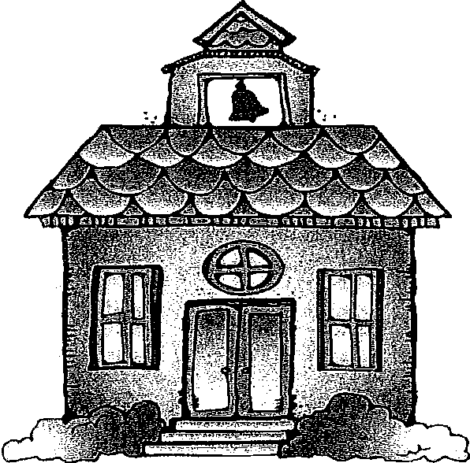

Records Required for Admission to Bennington Early Education Center

Before your child may attend the Bennington Early Education Center, you must provide to the school:

  - A photocopy of the child's state issued birth certificate (the one with the State Seal is preferable). This is required by legislation commonly known as the "Missing Children Identification Act".

  - You will also be required to fill out a Student Enrollment Form, which includes important information regarding who your child may be released to in the event that different transportation arrangements must be made, who to contact in case there is an emergency in which the parents cannot be reached, and important medical information questions, etc. This information will help us in providing a safe and healthy environment for your child.

  - IF NEEDED-if your child has any medical/health needs, a health plan must be completed for directions on steps to follow in case of a medical/health emergency.

4) A copy of your child’s most recent vaccinations/immunizations record.

Thank you for assisting us in complying with state requirements by providing this important information to us before your child begins school.

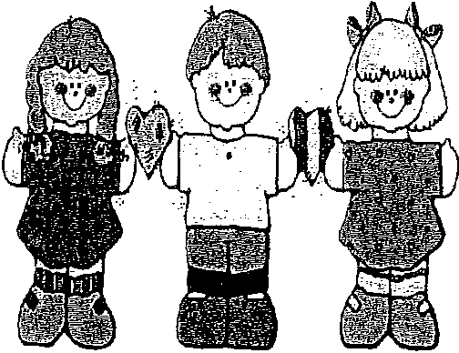

Peer Model Program

The Bennington Public Schools Preschool Peer Model Program is a vital part of our early childhood special education classroom instruction. The Peer Model Program provides typically developing children an opportunity to interact with same age peers who are receiving specialized instruction in a developmentally appropriate classroom. This “inclusion” program provides a stimulating and challenging environment that offers all children a wide range of learning opportunities.
Research-based practices tell us that typically developing peers are positive role models for students with disabilities. Inclusive preschool environments promote belonging, friendships, understanding and acceptance of others that are different. Research also states that typically developing children enrolled in an inclusive preschool setting develop meaningful relationships with their peers who have disabilities.
Children selected to serve as peer role models must demonstrate developmentally appropriate speech, language, social skills and behaviors. Peer Models are able to communicate clearly, interact well with others, model cooperative interactions and follow directions.

Students must model these age-appropriate preschool behaviors to remain in the peer program. Peer performance is monitored through a checklist, which is shared with parents during conferences. Inappropriate behavior or irregular attendance will result in dismissal from the program.

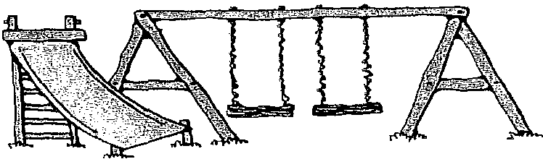

Individual Education Plans (IEP)
For those children receiving Special Education Services, an IEP will be developed following the testing (verification) and before the child is placed in the Bennington Early Education Center. This IEP will be reviewed on an annual or semi-annual basis. Parent input is vitally important in creating a complete and useful IEP. Parental participation in the IEP review is essential to program success and is required by state regulations. Every effort will be made to find an acceptable time and place for the parents to attend the review.
Personnel typically attending the IEP reviews may include teachers, therapists, and school district representatives. New goals and objectives developed from suggestions by those present at the review may be added to the IEP at this review. Progress reports and testing data may be discussed.

Parent-Teacher Conferences
Parent-Teacher Conferences will be held twice a year as shown on the school calendar. The conference will include the parents and the classroom teacher. I will send out a Sign-Up Genius email a couple of weeks before conference so you will be able to sign up for a time that fits your schedule the best.

Weekly Newsletter
A newsletter will be sent home at the end of the week to let you know what skills we worked on that week, who has snack for the following week, and any important reminders or dates that I need to let you know about.

Your Child at School
Toys, gum, money and candy should be enjoyed at home. When your child wants to bring something to school, we ask that you get permission from the teacher.
Please inform the staff in any information or circumstances which could impact your child's behavior (inability to sleep, newborn in the family, parent's absence, houseguests, etc.)

..
•
' ,.

Snacks
Snack time is an important and necessary part of our preschool routine. Many speech and language activities as well as fine motor activities can be practiced at snack time. If a child has any food allergies or special dietary needs or restrictions, we ask that the parent inform the teacher immediately.
We ask that parents provide the snacks for our class. When it is your turn, please send enough snacks for each day in the week for each person in the class. All snacks must be pre-packaged and purchased from a store. NO PEANUT PRODUCTS, OR PEANUT BUTTER SNACK ITEMS DUE TO ALLERGIES. You may also bring juice if you would like, if not, we will drink water. Please also send a box of 100 count, 5 oz. paper cups.

Birthdays
Many times parents wish to celebrate their child's birthday by sending treats close to or on their child's birthday. Please let the teacher know if you will be sending treats to celebrate your child’s birthday at school.

Class Parties/Room Parent
We will have 3 class parties this year (Halloween, Holiday, and Valentine’s Day). The party typically involves an activity/games, a craft, and a snack. These are planned by the room parents and other parents willing to help. I will have sign-up sheets at Open House or you can email me if you are interested.

School Clothes and Supplies
Sturdy shoes and play clothes enable you child to participate freely in all preschool activities. Let your child wear clothes he/she can easily manage for the bathroom. Avoid dressing your child in "best" clothes in case of spills and messy activities. The children are here to "learn by doing" and cannot do this if pressures are placed on them to stay neat and tidy at all times. Most types of sandals, flip flops, slick soled shoes and boots are not as safe or as adaptable to the preschool's equipment and activities. The best shoe choice is sneakers, or athletic shoes.
Please make sure your child always has a complete change of clothing, including socks and underwear, in their backpack at all times.
If your child wears pull-ups or diapers, please make arrangements to have enough supplies at school to accommodate your child's needs.
Please send a backpack to school every day for your child to transport his/her papers and other possessions. Good communication between school and home is necessary to foster children's development. Parents are encouraged to let teachers know significant events or information that may affect the child's mood or behavior that day. Also, teachers will send notes home as needed, so please check your child's backpack each day.

Field Trips
One field trip will be planned during the year to give your child opportunities to experience the world outside of the classroom and home on a first hand basis. Each child must have a signed and dated permission slip on file before they can participate in a field trip experience. Please be prompt in returning the permission slip for the field trip. We ask that you keep siblings at home or with a sitter.

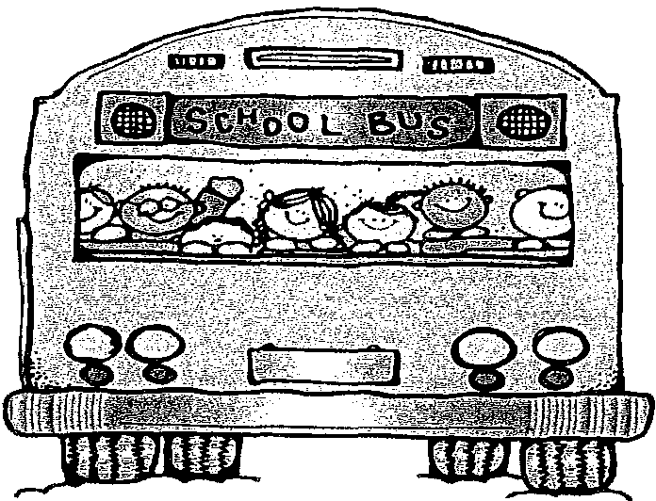

Arrival Time
Unless your child is transported to school by bus, please drop off your child during the arrival time of class on the schedule. The staff members have the time prior to carry out numerous responsibilities they have in conjunction with their positions.
The preschool uses the southwest doors of the elementary building by the gym. Do not leave your child standing at the entrance unsupervised. Please drop your child off with a staff member. The doors are locked, please wait outside until a preschool staff member is there. If you are running late, enter through the administration office doors on the southeast corner and bring your child to the preschool classroom. Preschoolers should be dropped off and picked up by an adult.

Dismissal Time
Promptness in picking up children is essential. The staff members have other responsibilities after the children leave, so please do your part in helping us to stay on schedule. If you know you will not be able to get to school to pick up your child on time, please call to inform the staff.

Medication
Whenever possible, medication should be administered at home, since preschoolers are at school for a short time each day.
When a student must take medication at school, the following procedure is to be followed:

- All medication is to be brought to the office when the student arrives at school.
- Only one week's supply shall be brought at a time unless otherwise
indicated by the parent and attending physician.
- For prescription medications, the label on the medication shall include the student's name, physician's name, date and directions to be followed.
This should contain the original container and label. Non-prescription medications should be brought to school in the original container.
- All medications will be stored in the office at all times. Students shall not keep medication with them.
- Medication will be given to the student in the office and in front of the school nurse, secretary, office para, or principal.

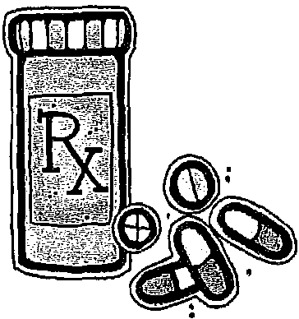

Snow Days /Inclement Weather
Please listen to KFAB-AM (1110 AM) or a local television station for school closings or early dismissals for the Bennington Public Schools.

Health

Please call the classroom teacher when your child is ill and will be absent from school. If your child rides the bus, please call Lyle's/Richie’s cell.

A child who is ill should be kept home from school until he/she is well enough to return to a normal routine. The following are guidelines to assist you in deciding when your child should stay home from school.

IRRITABILITY, HEADACHE, POOR APPETITE, TIREDNESS,
ACHINESS are vague symptoms. Changes in a child's normal behavior can often signal the beginning of an illness. An ill child is unable to benefit from school activities.

FEVER of 100 degrees or greater. Take your child's temperature if he/she complains of feeling tired, headache, sore throat or stomach ache. A child should be fever-free for 24 hours without the use of medication before returning to school.

NAUSEA, VOMITING, DIARRHEA Keep your child home as long as these symptoms occur. Be sure your child is able to tolerate fluids and food without difficulty before returning.

NASAL SECRETIONS AND COUGHING, SNEEZING spread respiratory infections easily when these symptoms can't be controlled. Remember some children in our classroom are very susceptible to infection.

SUSPECTED COMMUNICABLE CONDITIONS- UNDIAGNOSED RASHES, HEAD LICE, PINK EYE, RINGWORM, CHICKEN POX a child must be sent home until identified symptoms are evaluated and conditions of return to school are documented by a health care provider.

